

**SOI-2021-2120-0001**

Healthy you and me(WEB APp)

Date of Submission: 8 February 2022

Submitted By:

|  |  |
| --- | --- |
| 20009188 | Neo Angela |
| 20026236 | Uson Louise Airah Nicole S |
| 20007073 | Lee Jia Ye |

# ACKNOWLEDGEMENTS

Special thanks to Mr Florian for helping us in guiding us throughout these 12 weeks of coding journey. As we are learning and doing this project along the way, he would not be willing to guide us and help us even outside working hours. Greatly appreciate his effort for guiding us and produce this web application.

TABLE OF CONTENTS

ACKNOWLEDGEMENTS 2

ABSTRACT 4

1 Introduction 5

2 Project Specification and Plan 6

2.1 Project Overview 6

2.2 Functional Requirements 6

2.3 Project Plan 7

3 Business Analysis 8

3.1 Business Issues 8

3.2 Market Analysis 8

3.3 Business Solutions 8

4 System Design and Implementation 9

4.1 System Architecture 9

4.2 Detailed System Design 9

5 System Testing 10

6 User and Technical Documentations 11

6.1 User Documentation/Guide/Manual 11

6.2 Technical Documentation (Installation guide/Manual) 11

7 Conclusions 12

References 13

Appendices 14

Project Poster 15

# ABSTRACT

This project is about user creating more on physical and mental related information to share with others and assist web page admin to control the positivity of the content published by implementing AI to analyse emotions and vulgarities and let admin to make decision based on the AI analysis.

The breakdown is as follow:

* **Visitor**
* Register
* View articles, videos, programmes, questions, and supplements
* **Member**
* CRUD of Articles/Videos on health-related information
* Able to manage their own account through CRUD
* **Admin**
* Upload programme through excel to allow users to know about free on-going programmes from all around Singapore
* Upload members through excel to allow mass registration
* Read and export PDF to allow business analysis
* Make decision on emotional ad vulgarities text (AI)
* Able to identify a non-related health article (AI)
* CRUD for articles, videos, members, programmes, supplements, questions

# Introduction

Due to COVID-19, the suicidal rate for Singapore has risen to its highest of 452 cases ever since 2012. The goal of our web page is to not only help more user to get more information on physical health related projects, articles, video or programmes, and supplements but also to provide mental health support and motivate Singaporeans to lead a healthier mental and physical lifestyle.

With the completion of the Healthy, You and Me Web Application. Users will be able to navigate through the webpage to read create and update articles as well as read other articles, view supplements, participate in programmes, answer questions, watch videos to encourage them to lead a healthier lifestyle.

The major tasks that we will be doing are the web features such as CRUD of member, article, programmes and videos and web forms features to make it user friendly. We would also be using AI specifically text classification to help identify emotions through comments and identify offensive comments

# Project Specification and Plan

## Project Overview

The purpose of the project is to create an *ASP core Web based programme for individuals who aim to achieve a healthier lifestyle. Users such as admin and member can use the application for easy access to video, articles, programmes, questions of which the member can answer resources that will help guide them to gain more insights or meaning information that they need to support their healthy lifestyle journey. The use of AI will help the id in the tasks of admin by helping to detect emotions and negative comments for the articles and videos comment section.*

## Functional Requirements

**Functional Requirements**

**Visitor**

Register

View List of Articles

View List of Videos

View List of Supplements

View List of Members

View List of Questions

**Member**

Log in/ Log out

Manage own Account

Create, View and Update Videos

Create, View and Update Articles

Rate Articles

Rate Videos

Comment Videos

Comment Articles

View Programmes

Answer Questions

Post Questions

View Supplements

Search for other members

Search and Sort Articles

**Admin**

Log in/Log out

Manage own Account (CRUD)

Manage Videos (CRUD)

Manage Articles (CRUD))

Manage Supplement (CRUD)

Manage Programmes (CRUD)

Manage Questions (CRUD)

Archive Articles

Archive Questions

Change status of Articles (pending articles cannot deleted)

Import PDF

Export PDF

AI feature for the Articles to check offensive comments and to identify emotions

**Non - Functional Requirements**

There should not be duplicated members, articles, videos, programmes, and questions in database

**USE CASE DIAGRAM**

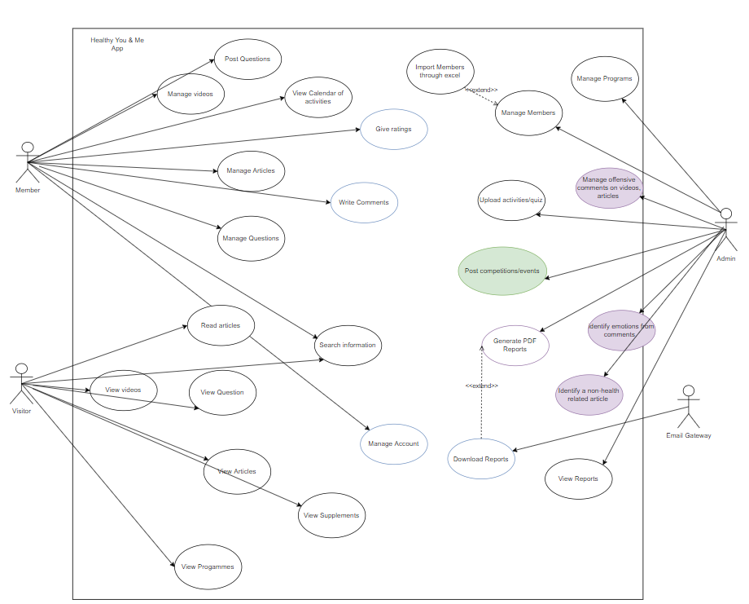

Purple – aided by AI

Green – Programmes can be hosted by external parties

## Project Plan

|  |  |  |
| --- | --- | --- |
| Angela | Jannice | Nicole |
| * Use case diagram  * Entity relationship diagram  *Database Design  *Use case Specifications: yellow  *Test Specifications: yellow  *User guide: yellow  *Source Codes: yellow | ***-*** * Entity relationship diagram  ***-*** *User guide: blue  *Source Codes: blue  *Technical Guide  *Test Specifications: blue  *Database Design  *Code integration | *Source Codes: pink  *User guide: pink  *Test Specifications: pink  *Use case diagram: pink  * Report  * Project Poster |

**Gannt Chart**

# Business Analysis

## Business Issues

Due to the Covid-19 pandemic there Is rise in the number of people seeking to live a healthier lifestyle both physically and mentally . With our application, we strive to provide a positive safe space to individuals who wants to learn and gain information on how to keep themselves fit and healthy and to achieve their desired health goals. Healthy You and Me web application acts as a social media platform where our members can share their own knowledge on how to keep healthy to be able to help others in finding the most suitable way to exercise and consuming the right supplements to fit their dietary needs or learn how to understand their emotions better.

This is an issue because the internet has a wide variety of resources, and it may be overwhelming for an individual to be able to start their healthy lifestyle journey. Through the implementation of the system, it will have users to save time and effort in finding resources that will be able to help them more effectively.

## Market Analysis

*Our starting business size is small, targeting the local community. There are several web applications that offer similar services, some examples are Health Hub and NUHS Health System whereby they have health related resources such as articles, programmes to kick start their health journey, they are also connected to government-based database system so that the individual can retrieve their own personal health records such as vaccination status etc. There are also mobile applications such as Prudential Pulse App and Lumi Health.*

## Business Solutions

***Process flow***

*If user is a member, the user can log in to application, if not the user can register. Once the member is logged in, he will be able to view the list of articles, members, videos, programmes, questions, and supplement. To create articles, questions, and supplement they will be prompted with a form to input their If they create the articles, videos, supplements they will be able to edit and delete the items that they create in the “My post” section.*

*If user is admin, once the admin is logged in, the admin will be able to create, read, update, and delete articles, members, videos, programmes, questions, and supplement. The AI implementation will help to check the comments if it is offensive before publishing. The admin will also have to check the articles, videos, questions, and supplement to see whether they are acceptable.*

***How can IT Help?***

*The use of IT will enable to consolidate the articles, members, videos, programmes, questions, and supplement all in one application. This benefit will allow easy access to the information that the user requires and reduce the need to refer to hardcopy resources which is more prone to loss of information. In addition, the use of IT can help with the exchange of information between users where they hope to achieve a similar health goal and improve overall user satisfaction. Furthermore, the use of AI features will help assist with the admin tasks and can improve the employee morale.*

# System Design and Implementation

## System Architecture

We will be using the ASP.Net Core Web App(Model-View-Controller) where In an MVC application, the Model represents the application's state as well as any business logic or operations that should be performed by it.

Views oversee the displaying content in the user interface.

Controllers are the components in charge of handling user interaction, interacting with the model, and finally deciding which view to render

## Detailed System Design

**

***ERD DIAGRAM***

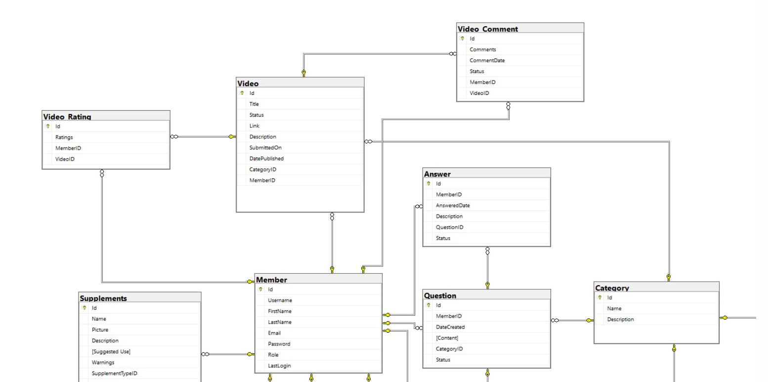

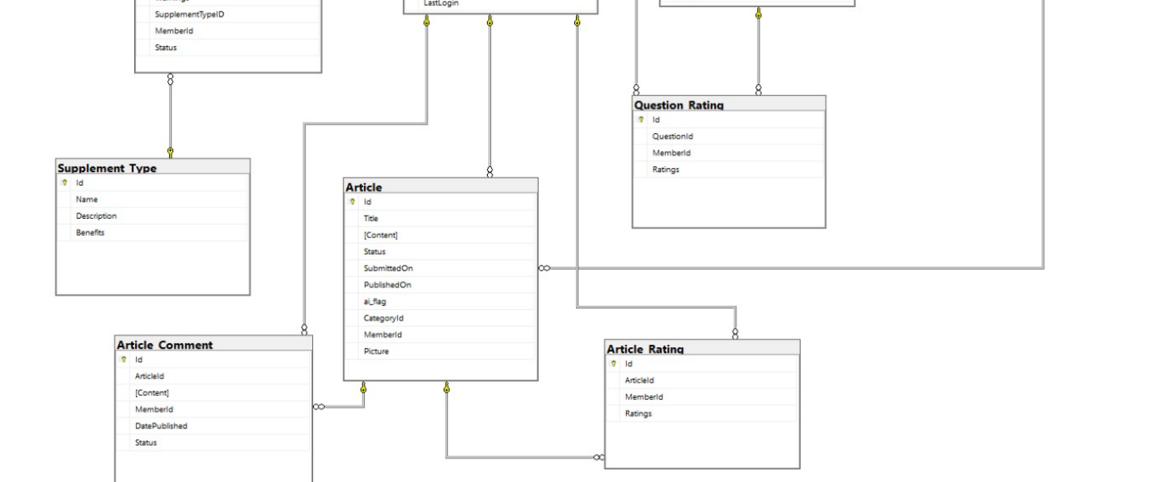

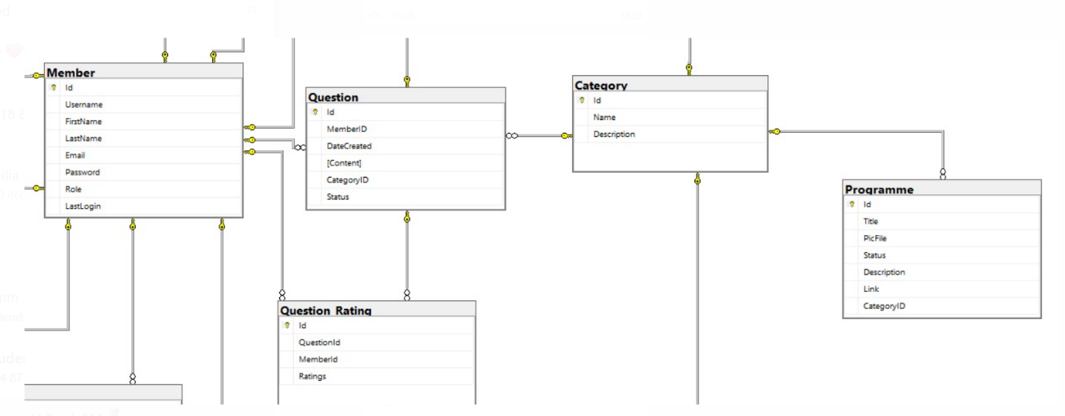

# System Testing



# User and Technical Documentations

## User Documentation/Guide/Manual

1.Existing user can log in or logout at the top right / Non existing user can register

2.Once logged in, User can navigate to see videos, articles, list of programmes currently going on, post comments and answer and comments to articles/videos and questions. They can choose to give and rating or comments to the post.

3.When the user clicked on article it will show a list of articles written by our members. Upon clicking on the specific article, it will show the details of the articles and allow user to add comments if they are login. If not they can only see the comments.

4. If the user posted unappropriated comments, there will be restrictions to it and our Admin will review the comments manually.

## Technical Documentation (Installation guide/Manual)

Installation guide



# Conclusions

*In this project, creating a functional web application was a unique experience worth struggling and working hard for. It was time consuming from the planning phase, executing the codes to searching for resources to help us program certain features that we want to achieve. Despite the challenges it was a rewarding experience and has taught us more on project development as well as our strengths and weaknesses as individuals.*

*The limitation that we faced was communication as it was hard to communicate due to the nature of working together as a team for the first time. In addition, we had to communicate through Ms teams due to the Covid-19 restrictions which has caused miscommunications and arguments that dragged the planning phase. Along the way, we managed to resolve our differences and worked well together from then on.*

*As the team was inexperienced in programming a web application, we stumbled occasionally as we had to juggle with being familiar with Visual Studios as well as learning how to implement the new functionalities at the same time. However, we were able to work well as a team and helped each other with any issues that we faced.*

*We manage to do CRUD for members, article, programmes, questions, supplements, and videos for admin as well allow the admin to approve the articles, questions, supplements, and videos that are created with the use of status. To ease the workload of the admin, the admin can import excel of the members, programmes, and supplement to be inserted into the database. Admin can also read and export articles in pdf based on rating and based on number of articles of a specific category. The member is also able to rate and comment the articles and videos. The use of AI text classification will help with checking on offensive comments for articles, video, and supplement. AI has implemented for the articles and questions to help check for emotions.*

*In the future, we would like to work on the interface to make it more user friendly as well as make it more aesthetically pleasing to attract more users and have a more consistent layout throughout with the use of GitHub/Axure Repository and more time should be dedicated to integration. We would want to develop this into a mobile application as well to make it more accessible for the user. Finally, we would want to restrict the views of the comments for the visitors and only the members are able to view the comments so that there will be more conversions of visitors to members.*

# References

*10 things I'm doing to be healthy*. This Reading Mama. (2018, February 7). Retrieved February 8, 2022, from <https://thisreadingmama.com/10-things-be-healthy/>

Sendgrid. (n.d.). *Sendgrid/sendgrid-csharp: The official Twilio SendGrid LED, community driven C#, .netstandard, .netcore API library*. GitHub. Retrieved February 8, 2022, from <https://github.com/sendgrid/sendgrid-csharp#hello-email>

HealthHub. (n.d.). Retrieved February 8, 2022, from <https://www.healthhub.sg/>

Healthline Media. (n.d.). *Medical Information and Health Advice You Can Trust.* Healthline. Retrieved February 8, 2022, from <https://www.healthline.com/>

YouTube. (n.d.). *Health Related Videos*. YouTube. Retrieved February 8, 2022, from <https://www.youtube.com/>

# Project Poster

**